**Midterm 1: Patrick Kim**

**Section 1.1: Systems of Linear Equations**

**Definitions**

* Linear equation
  + a1x1 + a2x2 + … + anxn = b
  + Organization of coefficients and variables with a solution ‘b’
* System of linear equations
  + Collection of multiple linear equations
* Solution of a system
  + (s1, s2, … ,sn)
  + List of numbers that make each equation a true statement when the s values are substituted for the x variables
* Solution set
  + Set of all possible solutions of a linear system
* Equivalent linear systems
  + 2 linear systems with the **same solution set**
* Consistent system
  + 1 solution or infinitely many solutions
* Inconsistent system
  + No solution for a **specific input**
* Existence
  + Does a solution set exist?
* Uniqueness
  + If a solution exists, is there more than one solution?

**Key Notes**

* A system of linear equations has either:
  + No solution
  + Exactly one solution
  + Infinitely many solutions
* Matrix notation
  + Rectangular format that contains info of a linear system
  + Example system
    - 1x1 - 2x2 + x3 = 0
    - 0x1 + 2x2 - 8x3 = 8
    - 5x1 + 0x2 - 5x3 = 10
  + Coefficient matrix
    - 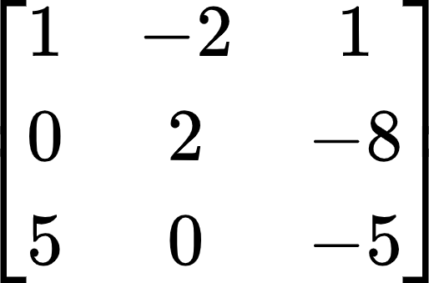
  + Augmented matrix
    - 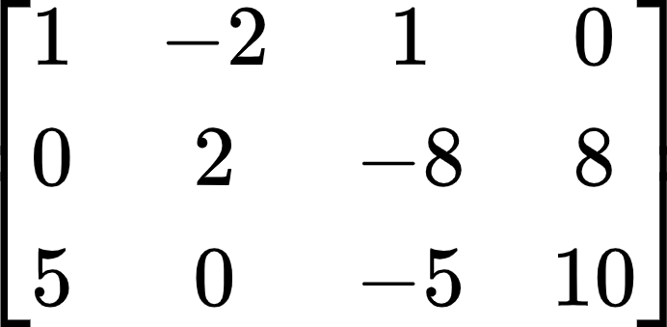
  + Size of a matrix
    - *m* x *n*
    - *m*: rows
    - *n*: columns
* Row reduction operations
  + Replacement
    - Eliminating elements (making them 0) by comparing two rows and scaling one of them
  + Interchange
    - Swapping rows
  + Scaling
    - Usually done to make a leading entry into one
* Goal of row reduction: to create an **echelon form** or **RREF**
  + Triangle of 0’s

**Section 1.2: Row Reduction and Echelon Forms**

**Definitions**

* Non-zero row/column
  + Row or column with **at least one** nonzero entry
* Zero row/column
  + Row or column with **all zeros**
* Leading entry
  + Leftmost nonzero entry in a row
* Row reduced echelon form (RREF)
  + A simplified matrix that represents a potential solution set for a linear system
  + Each matrix has only one RREF
* Pivot position
  + Location in a matrix that corresponds to a leading 1 in RREF
* Pivot column
  + Column that contains a pivot position
* Basic/leading variables
  + Variables that correspond to a pivot
  + Basic variables have an exact value for a solution set
* Free variables
  + Variables that do not correspond to any pivots and pivot columns
  + Can be assigned **any value** for a consistent linear system
* Overdetermined system
  + # of rows > # of columns
  + System of linear equations with more equations than unknowns
    - Can be consistent
    - Can have a unique solution
  + 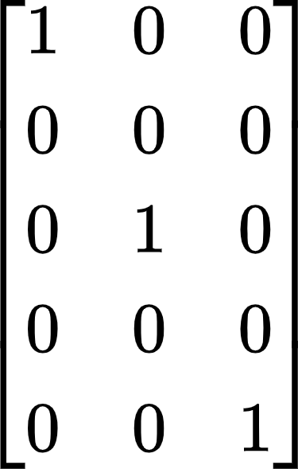
* Underdetermined system
  + # of columns > # of rows
  + System of linear equations with more unknowns than equations
  + Can **never** have a unique solution (always a **free variable**)
    - If system is consistent -> infinite solutions
    - If system is inconsistent -> no solution
  + 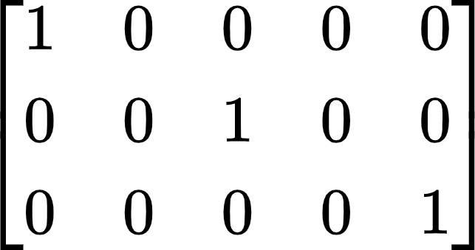

**Key Notes**

* Echelon Form of a Matrix
  + 3 Properties:

1. All zero rows are **at the bottom**
2. Each leading entry (non-zero entry) of a row is to the **right** of any leading entries in the row above it (if any)
3. Below a leading entry, all entries are 0

* RREF
  + All leading entries are 1’s
  + There are 0’s **above** **and below** each leading 1
* A matrix can be in **neither** echelon form nor RREF
  + This means that **more row reduction** needs to be done
* Uniqueness of the RREF
  + Each matrix is **row equivalent** (has same solution set) to **one and only one** reduced echelon matrix
    - A matrix has **only one RREF** matrix
* **Inconsistent** systems have **empty** solution sets
* Existence and Uniqueness Theorem
  + A linear system is consistent if and only if the rightmost column of the augmented matrix is **not** a pivot column
    - No row of the form:
      * [0 0 0 0 0 | b] with b non-zero
  + If a linear system is consistent, the solution set has either:
    - Unique solution (no free variables)
    - Infinitely many solutions (at least one free variable)

**Section 1.3: Vector Equations**

**Definitions**

* Vector
  + An ordered list of numbers
* Rn
  + R: collection of all lists of *n* real numbers
  + n: number of entries (rows) in the vector
* Zero vector: 0
  + Vector with all entries 0
* Linear combination
  + Given vectors {v1, v2, …, vp} in Rn and given scalars {c1, c2, …, cp}, a vector *y* defined by y = c1v1 + c2v2 + … + cpvp is a linear combination
* Span{v1 … vp}
  + Collection of all vectors that can be written in the form

c1v1 + c2v2 + … + cpvp

**Key Notes**

* Vectors in Rx
  + R2 vector: 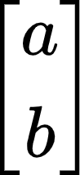
  + R3 vector: 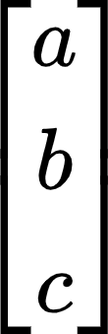
* Vectors in R2 can be represented as a line to a point in a 2D space
* Vectors in R3 can be represented as a line to a point in a 3D space
* Graphically adding vectors in R2
  + Add “tip to tail”
* Algebraic properties of Rn
  + For all u, v, w in Rn and all scalars c & d:

i. u + v = v + u v. c (u + v) = cu + cv

ii. (u + v) + w = u + (v + w) vi. (c + d) u = cu + du

iii. u + 0 = 0 + u = u vii. c (du) = (cd) u

iv. u + (-u) = -u + u = 0 viii. 1u = u

* A **vector equation x1a1 + x2a2 + … + xnan = b** has the same solution set as the linear system whose augmented matrix is [a1 a2 .. an | b]
  + b can be generated by a linear combination of a1, …, an if and only if there exists a **solution (weights: x1, …, xn)** to the linear system corresponding to the matrix
* If v1 … vp are in Rn, then the set of all linear combinations of v1 … vp is denoted by Span{v1 … vp} and is called the subset of Rn spanned by v1 … vp
  + Span{v1 … vp}: collection of all vectors that can be written in the form

c1v1 + c2v2 + … + cpvp

* Is vector b in Span{v1, …, vp}? == does x1v1 + x2v2 + … + xpvp = b have a solution?
  + Solve [v1 … vp | b]
  + Is b a linear combination of the vectors in {v1 … vp}?
    - **Is there a pivot in every row?**

**Section 1.4: The Matrix Equation Ax=b**

**Definitions**

* Identity matrix
  + The “one” of multiplying matrices
  + Outputs the same input
* x ∈ Rn
  + x is a vector with *n* elements

**Key Notes**

* Star Equation
  + Ax = 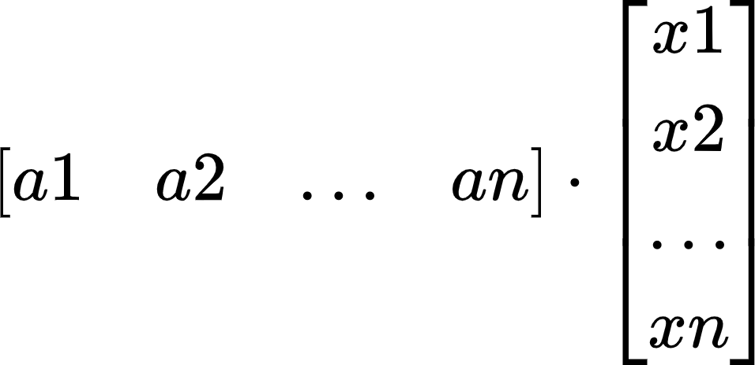 = x1a1 + x2a2 + … xnan
    - x: weights
    - Ax is defined only if the number of **columns in A** == number of **entries in x**
* If A is an *m* x *n* matrix, with columns a1, … an, and if *b* is in *Rm*:
  + Matrix equation == vector equation == augmented matrix for a linear system
  + (Ax = b) == (x1a1 + x2a2 + … + xnan = b) == ([a1 a2 … an | b])
* Ax = b as a linear combination has **two parts**

1. A vector
2. x vector
   * Span of the columns essentially means **multiplying** these **two parts**

* Ax = b has a solution if and only if *b* is a linear combination of the columns of A
* Logically equivalent statements for an *m* x *n* matrix A (all true or all false)
  + For each b in Rm, the equation Ax = b has a solution
  + Each b in Rm is a linear combination of the columns of A
  + The columns of A span Rm
  + A has a pivot position in every row
* If A is an *m* x *n* matrix, u & v are vectors in Rn, and c is a scalar, then:
  + A(u + v) = Au + Av
  + A(cu) = c(Au)

**Section 1.5: Solution Sets of Linear Systems**

**Definitions**

* Homogeneous linear system
  + System of linear equations written in the form: *A***x** = 0
* Trivial solution
  + x vector = 0
* Nontrivial solution
  + x vector that satisfies Ax = 0 and has **at least one** non-zero element
* Nonhomogeneous linear system
  + System of linear equations written in the form: *A***x** = **b**
  + Where b != 0

**Key Notes**

* Homogeneous linear system (Ax = 0) always has **at least one solution**
  + Trivial solution: x = 0
* Homogeneous system has a nontrivial solution if there is **at least one free variable**
* **Implicit** description of a plane
  + 10x1 - 3x2 - 2x3 = 0
* **Explicit** description of a plane (**Parametric Vector Equation**)
  + x = s**u** + t**v**
    - x: x vector
    - s, t in R
  + x = x2**u** + x3**v**
    - x2 and x3 are free variables
* Parametric Vector Form for a consistent …
  + Ax = b
    - x = u + tv
  + Ax = 0
    - x = tv
* For a consistent Ax = b, the solution set of Ax = b is the set of all vectors of the form

*w* = *p* + *vk*

where *p* is a solution and *vk* is any solution of Ax = 0

* Writing a solution set in Parametric Vector Form

1. Row reduce the augmented matrix to RREF
2. Express each basic variable in terms of any **free variable** appearing in an equation
3. Write a **typical solution x** as a vector whose entries depend on the free variables
4. Decompose **x** into a linear combination of vectors using the **free variables as parameters**
   1. Ex: 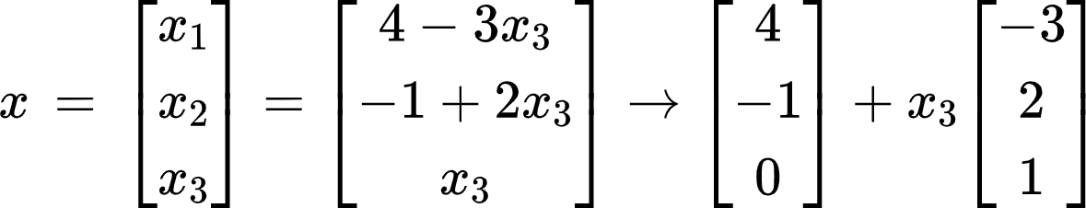

[*p*] [*v*]

**Section 1.7: Linear Independence**

**Definitions**

* Linearly independent
  + Vector equation *x1v1* + *x2v2* + … + *xpvp* = 0 has **only the trivial solution**
  + Matrix A has a **pivot in every column**
  + No free variables
* Linearly dependent
  + Vector equation *c1v1* + *c2v2* + … + *cpvp* = 0 where weights *c1*, … , *cp* are **not all zero**
  + At least one free variable

**Key Notes**

* If a set of vectors is **linearly independent**, there are **no free variables**
  + **No free variables** **= pivot in every column**
* If a set of vectors is **linearly dependent**, there is **at least one free variable**
* Quick facts
  + If # of columns > # of rows, then {v1, …, vp} is linearly dependent
    - 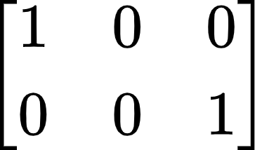: x2 is free
  + If {v1, …, vp} is linearly independent, then # of rows ≥ # of columns
    - 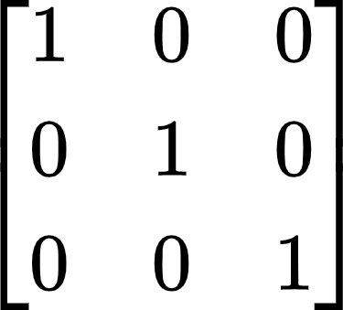: no free variables
    - 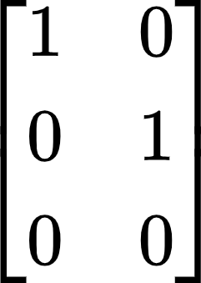: no free variables (there is no x3 here)
  + If Ax = 0 has a free variable, then {v1, …, vp} is linearly dependent
* Sets with **one vector**: x1v1
  + Linearly independent if and only if v1 is **not the 0 vector**
  + If v1 is the 0 vector -> x10
    - Has infinite nontrivial solutions
    - Linearly dependent
* Sets with **two vectors**: x1v1 and x2v2
  + Linearly **dependent** if at least one of the vectors is a **multiple** of the other
  + Linearly **independent** if and only if **neither** of the vectors is a multiple of the other
* Sets with **2 or more vectors**:
  + Linearly dependent if **at least one** of the vectors can be written as a **linear combination** of all the other vectors
  + One vector is **in the span** of the other vectors
    - Vector is a **multiple** of all the other vectors
* If at least one vector is the **zero vector**, then the system is **linearly dependent**

**Section 1.8: Introduction to Linear Transformations**

**Definitions**

* Matrix Transformation
  + Assigns (transforms) a vector **x** in Rn to a vector T(**x**) in Rm
* Linear Transformation
  + A matrix transformation that preserves the operations of vector addition and scalar multiplication
    - T(cu + dv) = cT(u) + dT(V)
* Domain of transformation *T*: *Rn* -> *Rm*
  + Input: set *Rn*
* Codomain of transformation *T*: *Rn* -> *Rm*
  + Output: set *Rm*
* Image of **x** under the action of *T*
  + *T*(**x**) in *Rm*
* Range of *T*
  + Set of all images *T*(**x**)
* Principle of superposition
  + *T*(c1**v1** + … + ck**vk**) = c1T**v1** + … + ckT**vk**

**Key Notes**

* (Solving equation Ax = b) == (finding all vectors **x** in Rn that are transformed into the vector **b** in Rm under the “action” of multiplication by A
* Let A be an *m* x *n* matrix -> derive a function:
  + Matrix transformation: *T*: *Rn* -> *Rm*, T(**x**) = A**x**
  + Multiplier (*A*): *m x n*
  + Domain of *T*: *Rn*
    - Number of entries in **x**
  + Codomain of *T*: *Rm*
    - Number of entries in *T*(**x**): image of **x** under *T*
  + Vector *T*(**x**)
    - Image of **x** under *T*
  + Range
    - Set of all possible images *T*(**x**)
* *T*: *Ry ->* Rx
  + T has *x* rows and *y* columns
* A transformation *T* is **linear** if:

i. *T* (**u** + **v**) = *T* (**u**) + *T* (**v**) for all **u**, **v** in the domain of *T*

ii. *T* (c**u**) = c (*T***u**) for all scalars c and all **u** in the domain of *T*

* + Example:
    - y = 2x
      * f(2 + 3) = f(2) + f(3): linear
    - y = x2
      * f(2 + 3) ≠ f(2) + f(3): not linear
* Every matrix transformation is a linear transformation
* *T*(**x**) = r**x**
  + Contraction: 0 ≤ r < 1
  + Dilation: r > 1

**Section 1.9: The Matrix of a Linear Transformation**

**Definitions**

* Standard matrix for a linear transformation *T*
  + *A* = [*T*(e1) + … + *T*(en)]
* e1 in R2=  e2 in R2=
* Onto (existence question)
  + T: Rn -> Rm is **onto** Rm if each **b** in Rm is the image of **at least one x** in Rn
    - At least 1 solution of T(**x**) = **b**
    - Pivot in **every row**
    - Columns of A **spans Rm**
* One-to-one (uniqueness question)
  + T: Rn -> Rm is **one-to-one** if each **b** in Rm is the image of **at most one** **x** in Rn
    - T(**x**) = **b** has either **1** **solution** or **no solutions**
    - Pivot in **every column**
    - Columns of A are **linearly independent**

**Key Notes**

* Every linear transformation from *Rn* to *Rm* is also a matrix transformation **x** ↦ A**x**
  + Finding *A*: observe what *T* does to the **standard matrix**
* Geometric Linear Transformations of *R*2
  + Reflections
    - Reflection through the x1 axis: 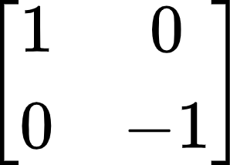
    - Reflection through the x2 axis: 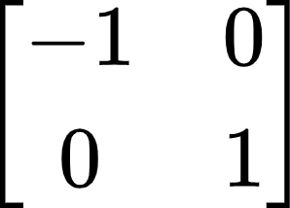
    - Reflection through the line x2 = x1: 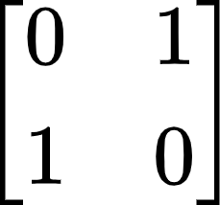
    - Reflection through the line x2 = -x1: 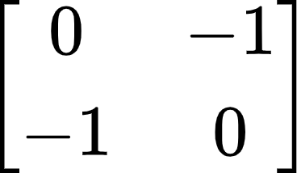
    - Reflection through the origin: 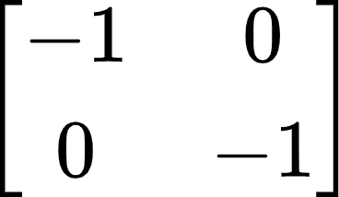
  + Contractions & expansions
    - 0 < k < 1: contraction
    - k > 1: expansion
    - Horizontal contraction & expansion: 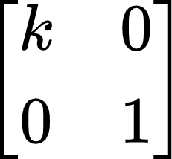
    - Vertical contraction & expansion: 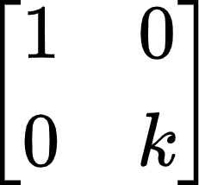
  + Shears
    - Horizontal shear: 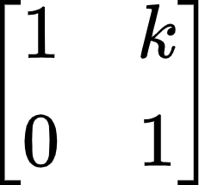
      * k < 0: left shear
      * k > 0: right shear
    - Vertical shear: 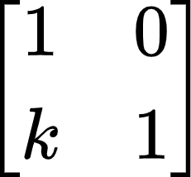
      * k < 0: down shear
      * k > 0: up shear
  + Projections
    - Projections on the x1-axis: 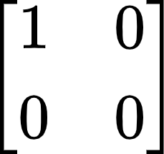
    - Projections on the x2-axis: 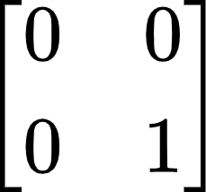
  + Rotation
    - CCW rotation: 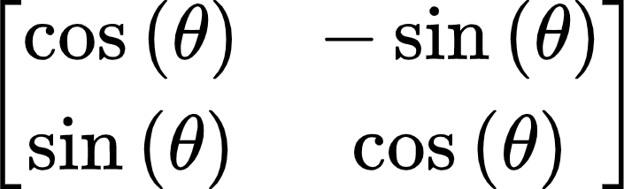
* Geometric description
  + Onto: can get to any vector with an image
  + One-to-one: cannot have multiple vectors have the same image
* Onto
  + A linear transformation T: Rn -> Rm is **onto** if for all **b** ∊ Rm there is an **x** ∊ Rn so that T(**x**) = A**x** = **b**
    - A**x** = **b** is **always consistent**
    - **At least** one solution
    - Existence property
  + T is onto if and only if its **standard matrix** has a **pivot in every row**
* One-to-one
  + A linear transformation T: Rn -> Rm is one-to-one if for all **b** ∊ Rm there is **at most** **one** (possible 0) **x** ∊ Rn so that T(**x**) = A**x** = **b**
    - A**x** = **b** has **at most 1** solution
    - No free variables
    - Uniqueness property
  + T is one-to-one if and only if the only solution to T(**x**) = **0** is the **trivial solution**
  + T is one-to-one if and only if **every column** of A is **pivotal**

**Section 2.1: Matrix Algebra**

**Key Notes**

* **Theorem 1**
  + Let A, B, and C be matrices of the same size, and let *r* and *s* be scalars.

a. A + B = B + A d. *r* (A + B) = *r*A + *r*B

b. (A + B) + C = A + (B + C) e. (*r* + *s*) A = *r*A + *s*A

c. A + 0 = A f. *r* (*s*A) = (*rs*) A

* Matrix multiplication
  + If A is an *m* x *n* matrix, and if B is an *n* x *p* matrix with columns b1, …, bp, then the product AB is the *m* x *p* matrix whose columns are Ab1, …, Abp

AB = A[b1 b2 … bp] = [Ab1 Ab2 … Abp]

* + # of columns in A == # of rows in B
* **Theorem 2: Properties of Matrix Multiplication**
  + Let A be an *m* x *n* matrix, and let B and C have sizes for which the indicated sums and products are defined.

a. A (BC) = (AB) C

b. A (B + C) = AB + AC

c. (B + C) A = BA + BC

d. r (AB) = (rA) B = A (rB)

e. ImA = A = AIn

* Matrices that **commute**
  + Matrices A and B commute when AB = BA
* Warnings
  + **Order** when multiplying matrices **matters**
    - In general, AB **≠** BA
  + AB = AC does not suggest B = C
  + If AB is the zero matrix, cannot conclude in general that either A = 0 or B = 0
* Transpose of a Matrix
  + Given an *m* x *n* matrix, the transpose of A is the *n* x *m* matrix, denoted by AT
  + 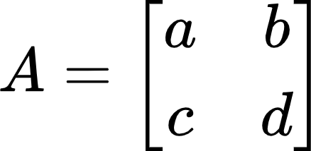 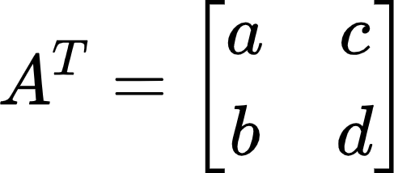
  + 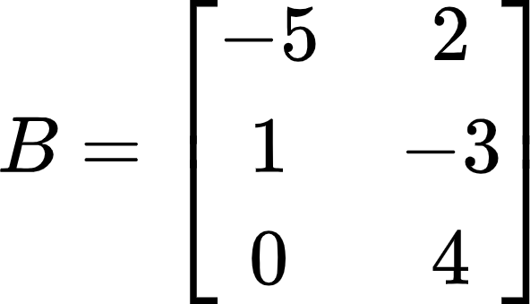 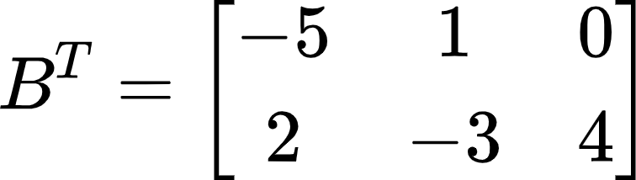
* **Theorem 3**
  + Led A and B denote matrices whose sizes are appropriate for the following sums and products

a. (AT)T = A

b. (A + B)T = AT + BT

c. For any scalar r, (rA)T = rAT

d. (AB)T = BTAT

* + The **transpose** of a product of matrices equals the product of their transposes in the **reverse order**
* Powers of Matrices
  + Can **only** be applied to **square matrices**

**Theorems**

**Theorem 1: Uniqueness of RREF**

* Each matrix is row equivalent to one and only one row reduced echelon matrix.

**Theorem 2: Existence and Uniqueness Theorem**

* A linear system is consistent if and only if the rightmost column of the augmented matrix is **not** a pivot column - that is, if and only if an echelon form of the augmented matrix has **no** row of the form:

[0 … 0 *b*] with *b* nonzero

* If a linear system is consistent, then the solution set contains either:

i. a unique solution (no free variables)

ii. infinitely many solution (at least one free variable)

**Theorem 3: Matrix, Vector, and Linear Equations**

* If *A* is an *m* x *n* matrix, with columns **a1, … , an** and if **b** is in Rm, the matrix equation

*A***x** = **b**

* has the same solution set as the vector equation

x1**a1** + x2**a2** + … + xn**an** = **b**

* which, in turn, has the same solution set as the system of linear equations whose augmented matrix is

[**a1** **a2 … an** | **b**]

**Theorem 4: Logically Equivalent Statements**

* Let *A* be an *m* x *n* matrix. Then the following statements are logically equivalent. That is, for a particular *A*, either they are all true statements or they are all false.

1. For each **b** in Rm, the equation A**x** = **b** has a solution.
2. Each **b** in Rm is a linear combination of the columns of A.
3. The columns of A span Rm.
4. *A* has a pivot position in every row.

**Theorem 5: Properties of the Matrix-Vector Product Ax**

* If *A* is an *m* x *n* matrix, **u** and **v** are vectors in Rn, and *c* is a scalar, then:

1. *A* (**u** + **v**) = *A***u** + *A***v**
2. *A* ( *c***u** ) = *c* (*A***u**)

**Theorem 6: Parametric Vector Form of a Nonhomogeneous System**

* Suppose the equation *A***x** = **b** is consistent for some given **b**, and let **p** be a solution. Then the solution set of *A***x** = **b** is the set of all vectors of the form **w** = **p** + **v***h*, where **v**h is any solution of the homogeneous equation *A***x** = 0.

**Theorem 7:** **Characterization of Linearly Dependent Sets**

* An indexed set *S* = {**v1**, …, **vp**} of two or more vectors is linearly dependent if and only if at least one of the vectors in *S* is a linear combination of the others. In fact, if *S* is linearly dependent and **v1** ≠ **0**, then some **vj** (with *j* > 1) is a linear combination of the preceding vectors, **v1**, …, **vj-1**.

**Theorem 8: Linear Dependence based on Matrix Size**

* If a set contains more vectors than there are entries in each vector, then the set is linearly dependent. That is, any set {**v1**, …, **vp**} in Rn is linearly dependent if the number of columns > than the number of rows.

**Theorem 9: Linear Dependence based on a Zero Vector**

* If a set *S* = {**v1**, …, **vp**} in Rn contains the zero vector, then the set is linearly dependent.

**Theorem 10: Using the Standard Matrix to find Columns of A**

* Let *T*: *Rn* -> *Rm* be a linear transformation. Then there exists a unique matrix *A* such that

*T*(**x**) = *A***x** for all **x** in Rn

* In fact, *A* is the *m* x *n* matrix whose *j*th column is the vector *T*(**e***j*), where **e***j* is the *j*th column of the identity matrix in Rn

*A* = [*T*(**e**1) … *T*(**e**n)]

**Theorem 11: One-to-One using the Homogeneous Equation**

* Let *T*: *Rn* -> *Rm* be a linear transformation. Then *T* is one-to-one if and only if the equation *T*(**x**) = **0** has only the trivial solution

**Theorem 12: Onto and One-to-One**

* Let *T*: *Rn* -> *Rm* be a linear transformation, and let *A* be the standard matrix for *T*. Then:

a. *T* maps *Rn* onto *Rm* if and only if the columns of *A* span *Rm*

* All rows have pivots

b. *T* is one-to-one if and only if the columns of *A* are linearly independent

* All columns have pivots
* A has linearly independent columns